EXP 14

**Create a Snapshot of a VM and Test it by loading the Previous Version/Cloned VM**

STEP 1:To create a new virtual machine tap the create new virtual machine

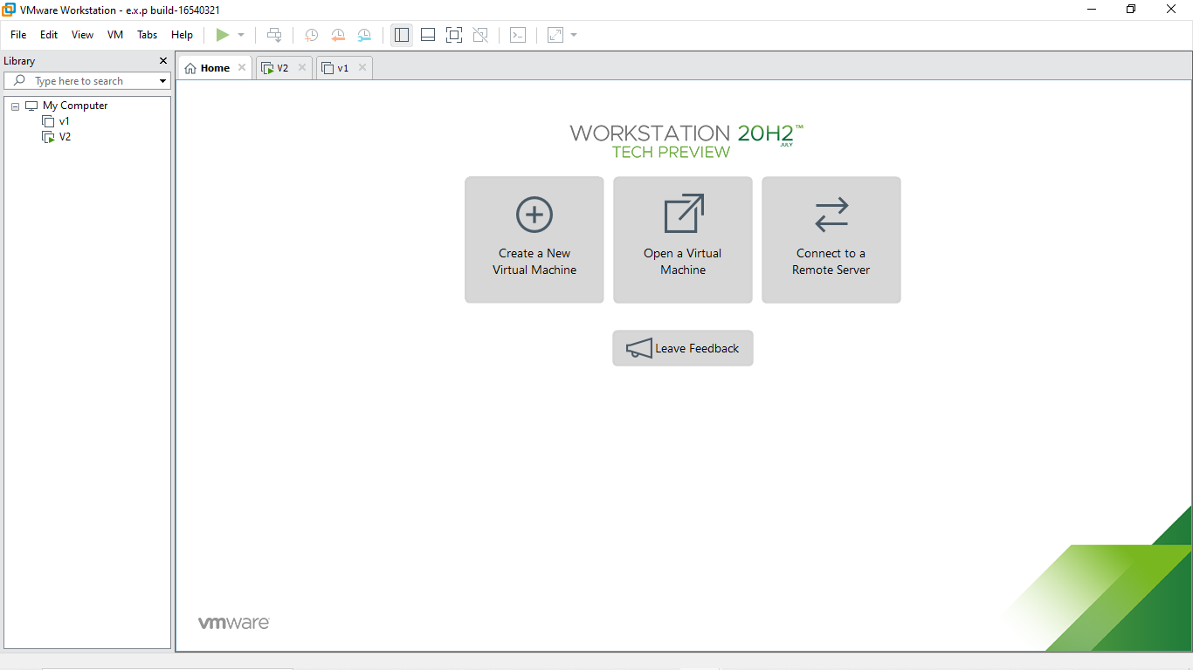

STEP 2: And the next process is to be the guest operating installation

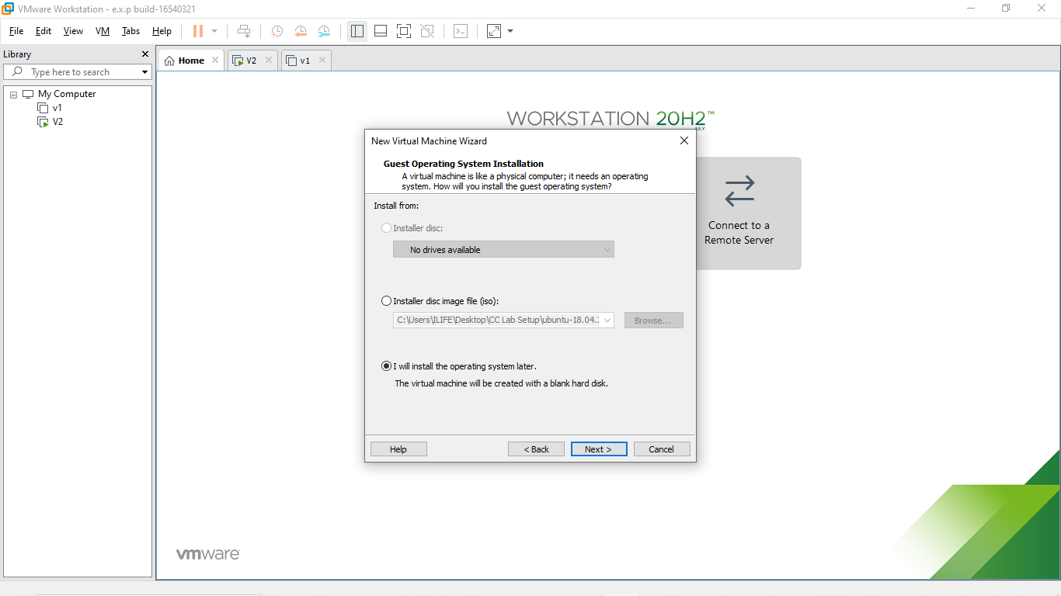

R.Akash 192121091

STEP 3: Select the guest operating system

STEP 4: Name the virtual machine

R.Akash 192121091

STEP 5: Specify the disk capacity and store a virtual machine as a single file

STEP 6: Read to crate virtual machine and click the finish button

R.Akash 192121091

STEP 7: Before snapshot created the new virtual machine

STEP 8: Take a Snapshot

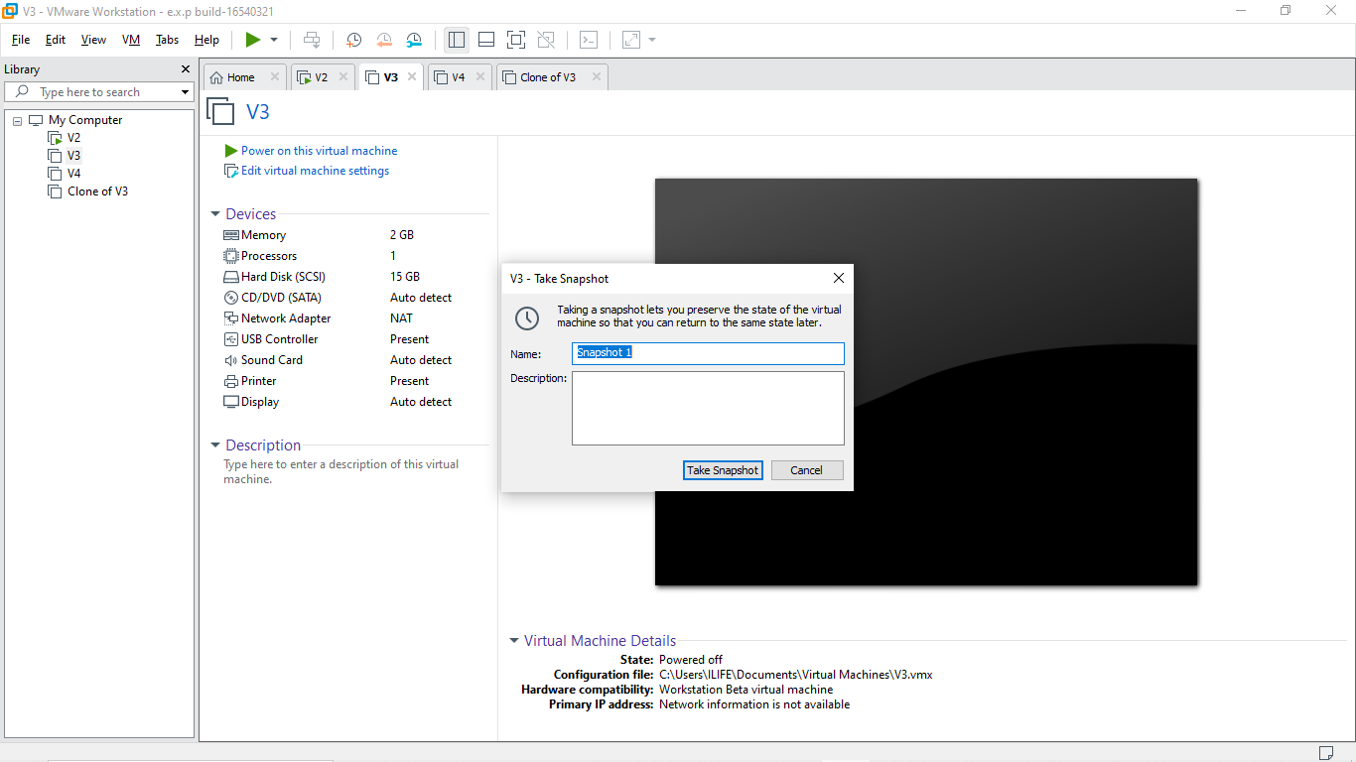

R.Akash 192121091

STEP 9: Change the memory size and take snapshot 2

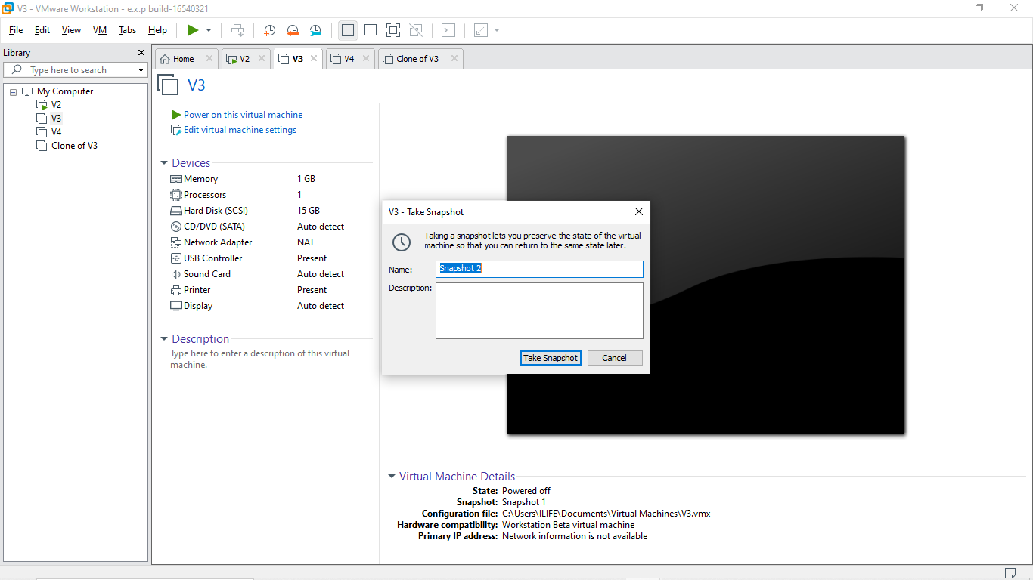

STEP 10: Change the processor and take snapshot 3

R.Akash 192121091

STEP 11: Go to the Snapshot manager and click the goto button

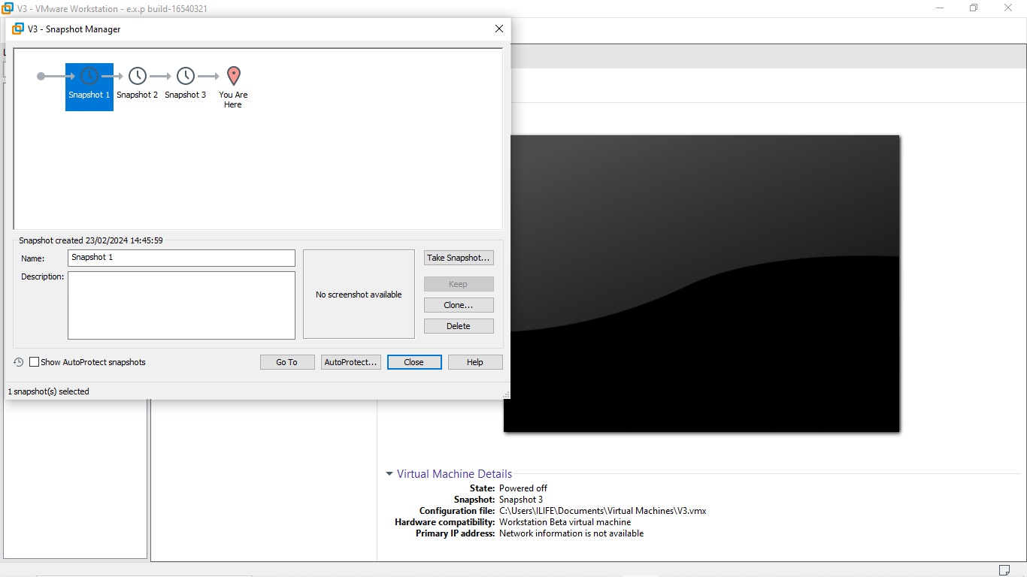

STEP 12: After the snapshot the virtual machine

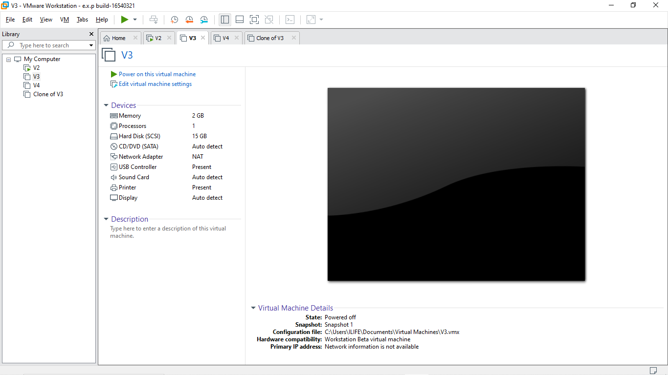

R.Akash 192121091